for jenkins notes

first i made a cloud server cloudocean

-connect to the ubuntu server i made via ssh

command : ssh root@ipaddr

-add java8 on ubuntu server

command: sudo add-apt-repository ppa:webupd8team/java

sudo apt-get update

sudo apt install openjdk-8-jdk openjdk-8-jre

-to download jenkins on ubuntu server

links: https://www.jenkins.io/doc/book/installing/linux/

https://phoenixnap.com/kb/install-jenkins-ubuntu

-to view that jenkins is active on the machine

command: systemctl status jenkins

-to open jenkins

find what your machine ip addr and open it on a browser with port 8080

a web page will appear to enter the password that is requested go to the machine

and type: cat /var/lib/jenkins/secrets/initialAdminPassword

copy the password to the browser and continue the procuder

to start and stop jenkins

command: systemctl start/stop jenkins

to install GIT on jenkins go to manage plugins from manage jenkins then search for "git integration"

to configure the java and git on jenkins go to Global configuration tool and add each one of them manually by adding there location from the machine "search for java/Git directory"

to add a new maven project on jenkins:

1- go to new item

2- connect to github source code

3-from build add maven build

4- press advance to add the path of the pom.xml from github

to set the time to trigger a build go to Poll SCM and put a schedule

to build a maven project

1. create a new item
2. put url of the github code in Git in source code mangement
3. in Build addinvoke topoo level marven
4. Goals should be test install
5. press advance to add the directory of maven in POM ex: mavensample/simple-moudle/pom.xml

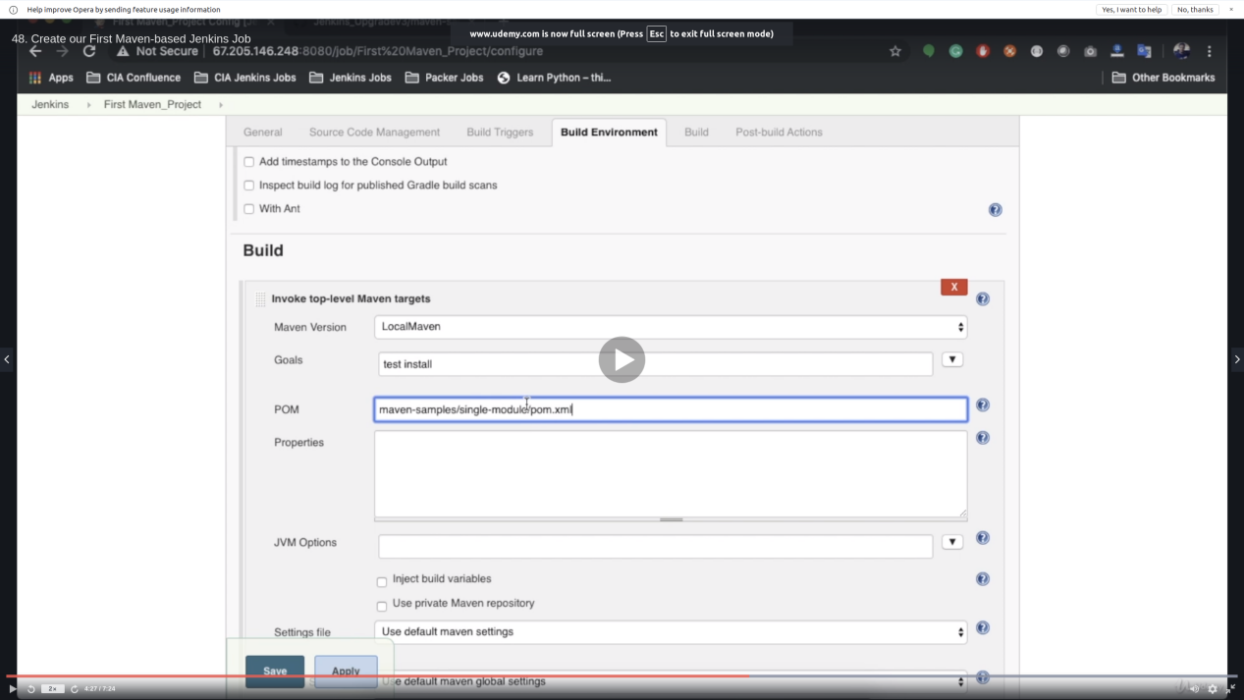

Install Tomcat On Linux/Unix Box & Configure with Jenkins

Step 1: Install Java

1. sudo apt-get update
2. sudo apt-get install default-jdk

Step 2: Install Tomcat

1. sudo apt install unzip wget
2. cd /tmp
3. wget http://mirrors.estointernet.in/apache/tomcat/tomcat-8/v8.5.47/bin/apache-tomcat-8.5.47.zip
4. unzip apache-tomcat-\*.zip
5. sudo mkdir -p /opt/tomcat
6. sudo mv apache-tomcat-8.5.47 /opt/tomcat/

Step 3: Change Tomcat Server Port

Jenkins is running on Port 8080, and tomcat defalut port is also 8080. So we need to change the Tomcat port, I am changing it to 9090

Go to /opt/tomcat/apache-tomcat-8.5.47/conf/server.xml file

Search for Connector and change the Port Value, save the file.

Step 4: Change Permission of Scripts in /bin

1. cd /opt/tomcat/apache-tomcat-8.5.47/bin
2. ls -la
3. sudo chmod +x \*

Step 5: Start tomcat server and accss via browser on port 9090

/opt/tomcat/apache-tomcat-8.5.47/bin/startup.sh

Step 6: Configure Jenkins with Tomcat for Auto Deployment of Artifacts.

Set Credentials of Tomcat that Jenkins use.

cd /opt/tomcat/apache-tomcat-8.5.47/conf

update tomcat-users.xml file.

roles : manager-script & admin-gui

Set password : tomcat

Step 6 : Restart the tomcat server

1. /opt/tomcat/apache-tomcat-8.5.47/bin/shutdown.sh
2. /opt/tomcat/apache-tomcat-8.5.47/bin/startup.sh

Fullscreen

to install Jenkins DSL ....go to Manage plugins ---> available----> job DSL

To add a new DSL project:

1. new item with a description
2. add a github code
3. in Build press Process job DSLs
4. in DSL Script add groovy file which is in github ex:MavenProjectDSL.groovy “no directory only file name”

5-after building the project you will get an error “script not yet approved for use”

6-to overcome this error go to Manage Jenkins

7- press In-process script Approval

8-press approve at the top

9-if you build now it will work